Linux Fundamentals
================================================================
Submitted to Vikul_Sir
Submitted by Nalathati Rahul
Submission Date –03/Feb/2026
================================================================
L5 - Create two AWS EC2 Ubuntu Instances to establish SSH Connection and SCP the files from one Instance to another instance
Step: 1 login to AWS console and go to EC2 service
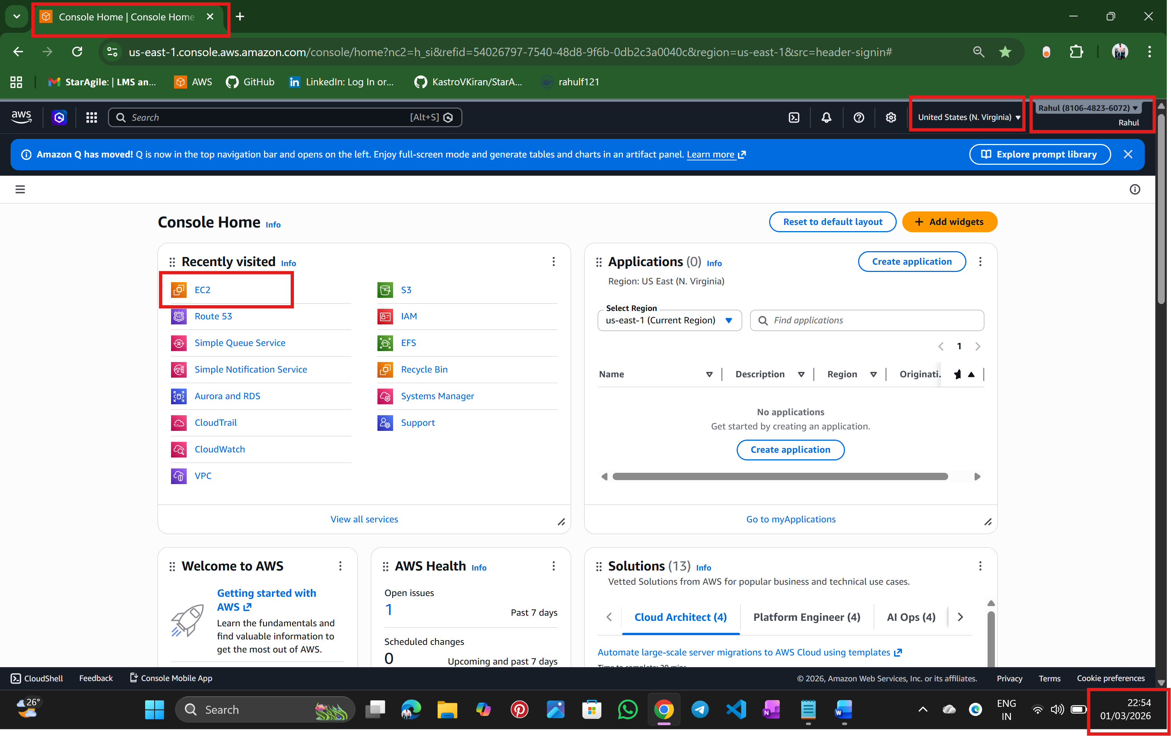
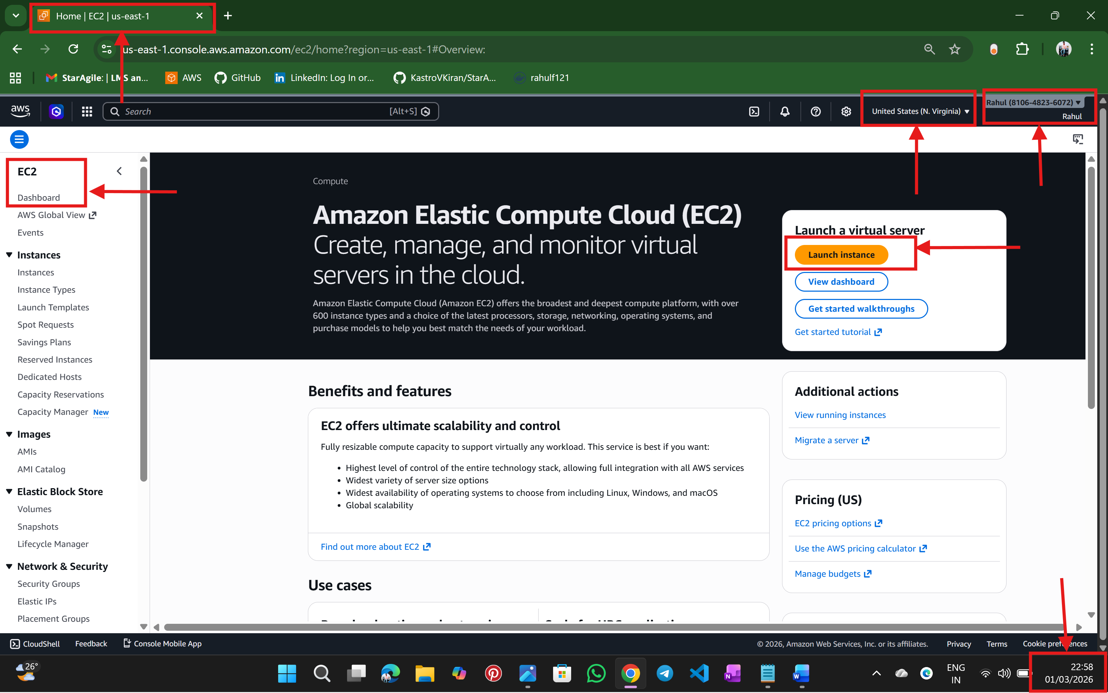

Step:2 create two instances
Instance -1
Instance -2
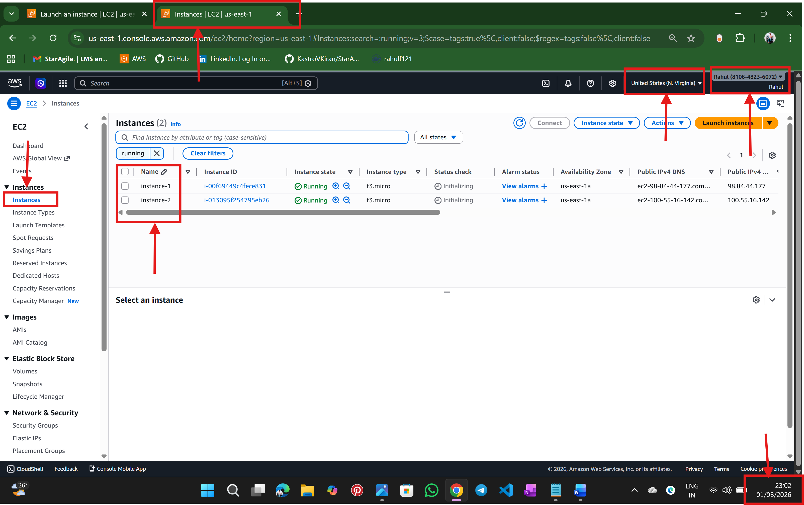
Step:3 Below window for instance -1 details

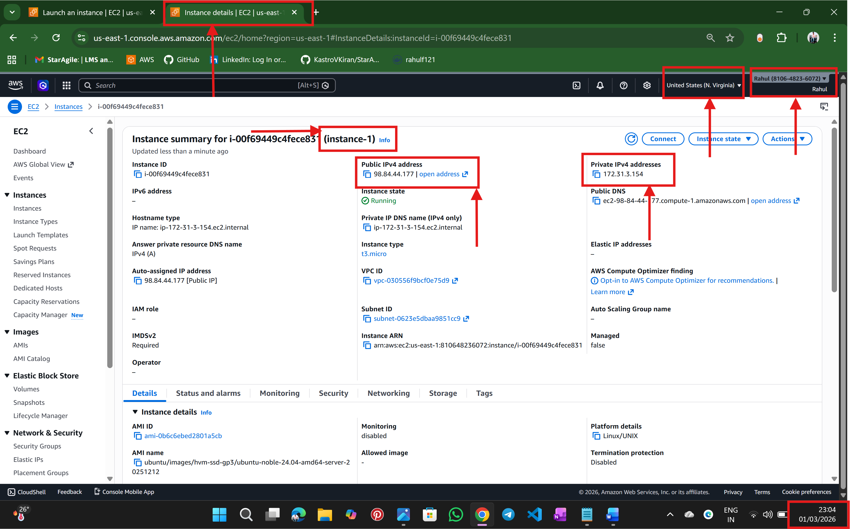

Step :4 Below window for instance -2 details
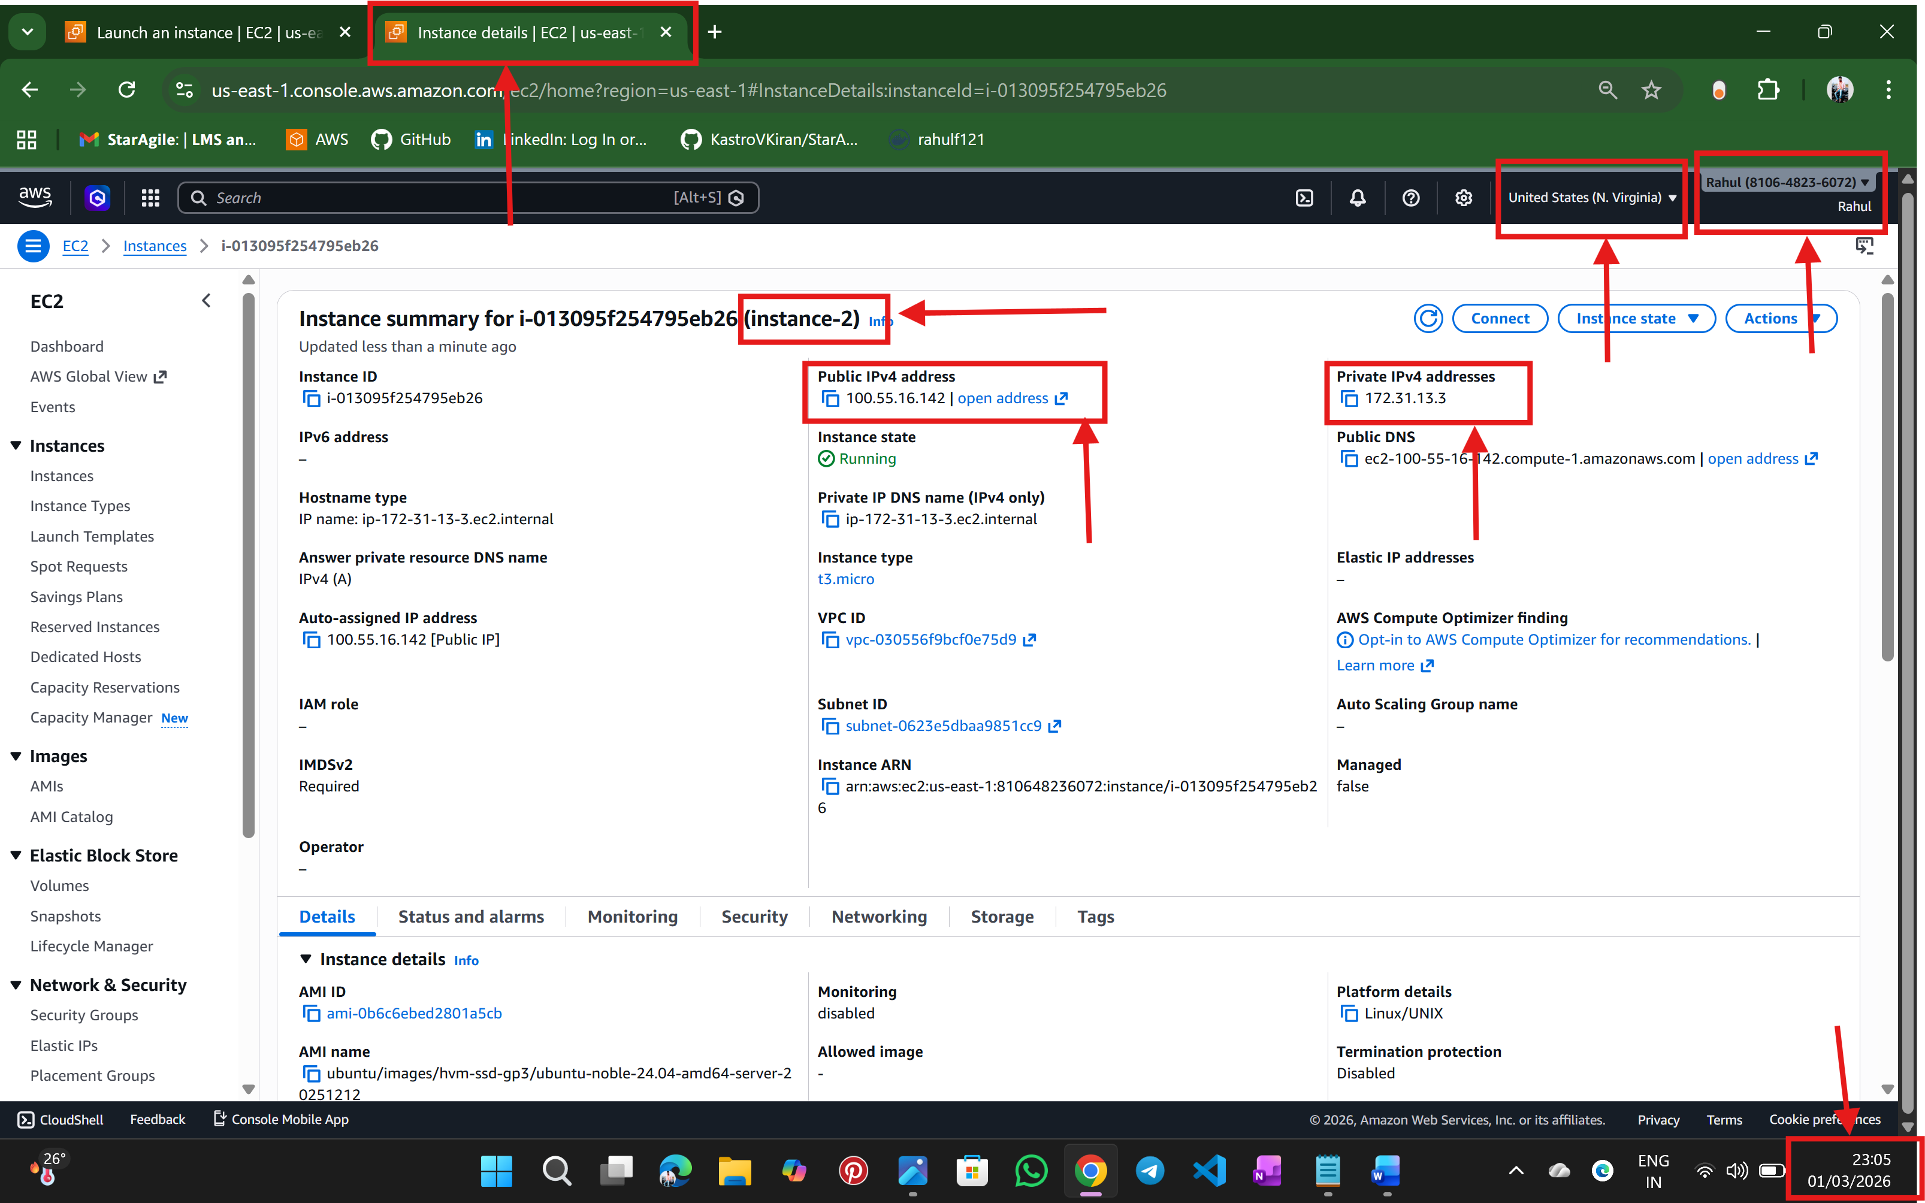

Step:5 from the local terminal, connect to instance -1
Set correct permission inside Instance 1 and SSH into Instance 1
create files inside instance-1
copy the files using SCP by using command scp -i qa@14.pem testfile.txt ubuntu@172.31.8.192:/home/ubuntu/ so copied from instance -1 to instance -2
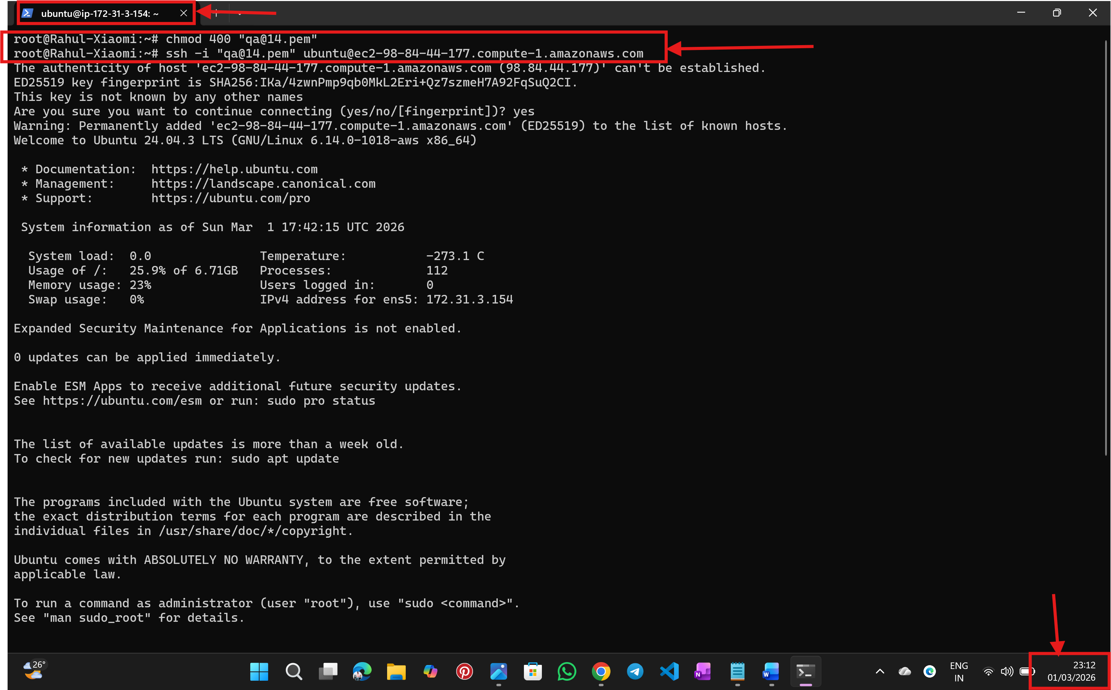

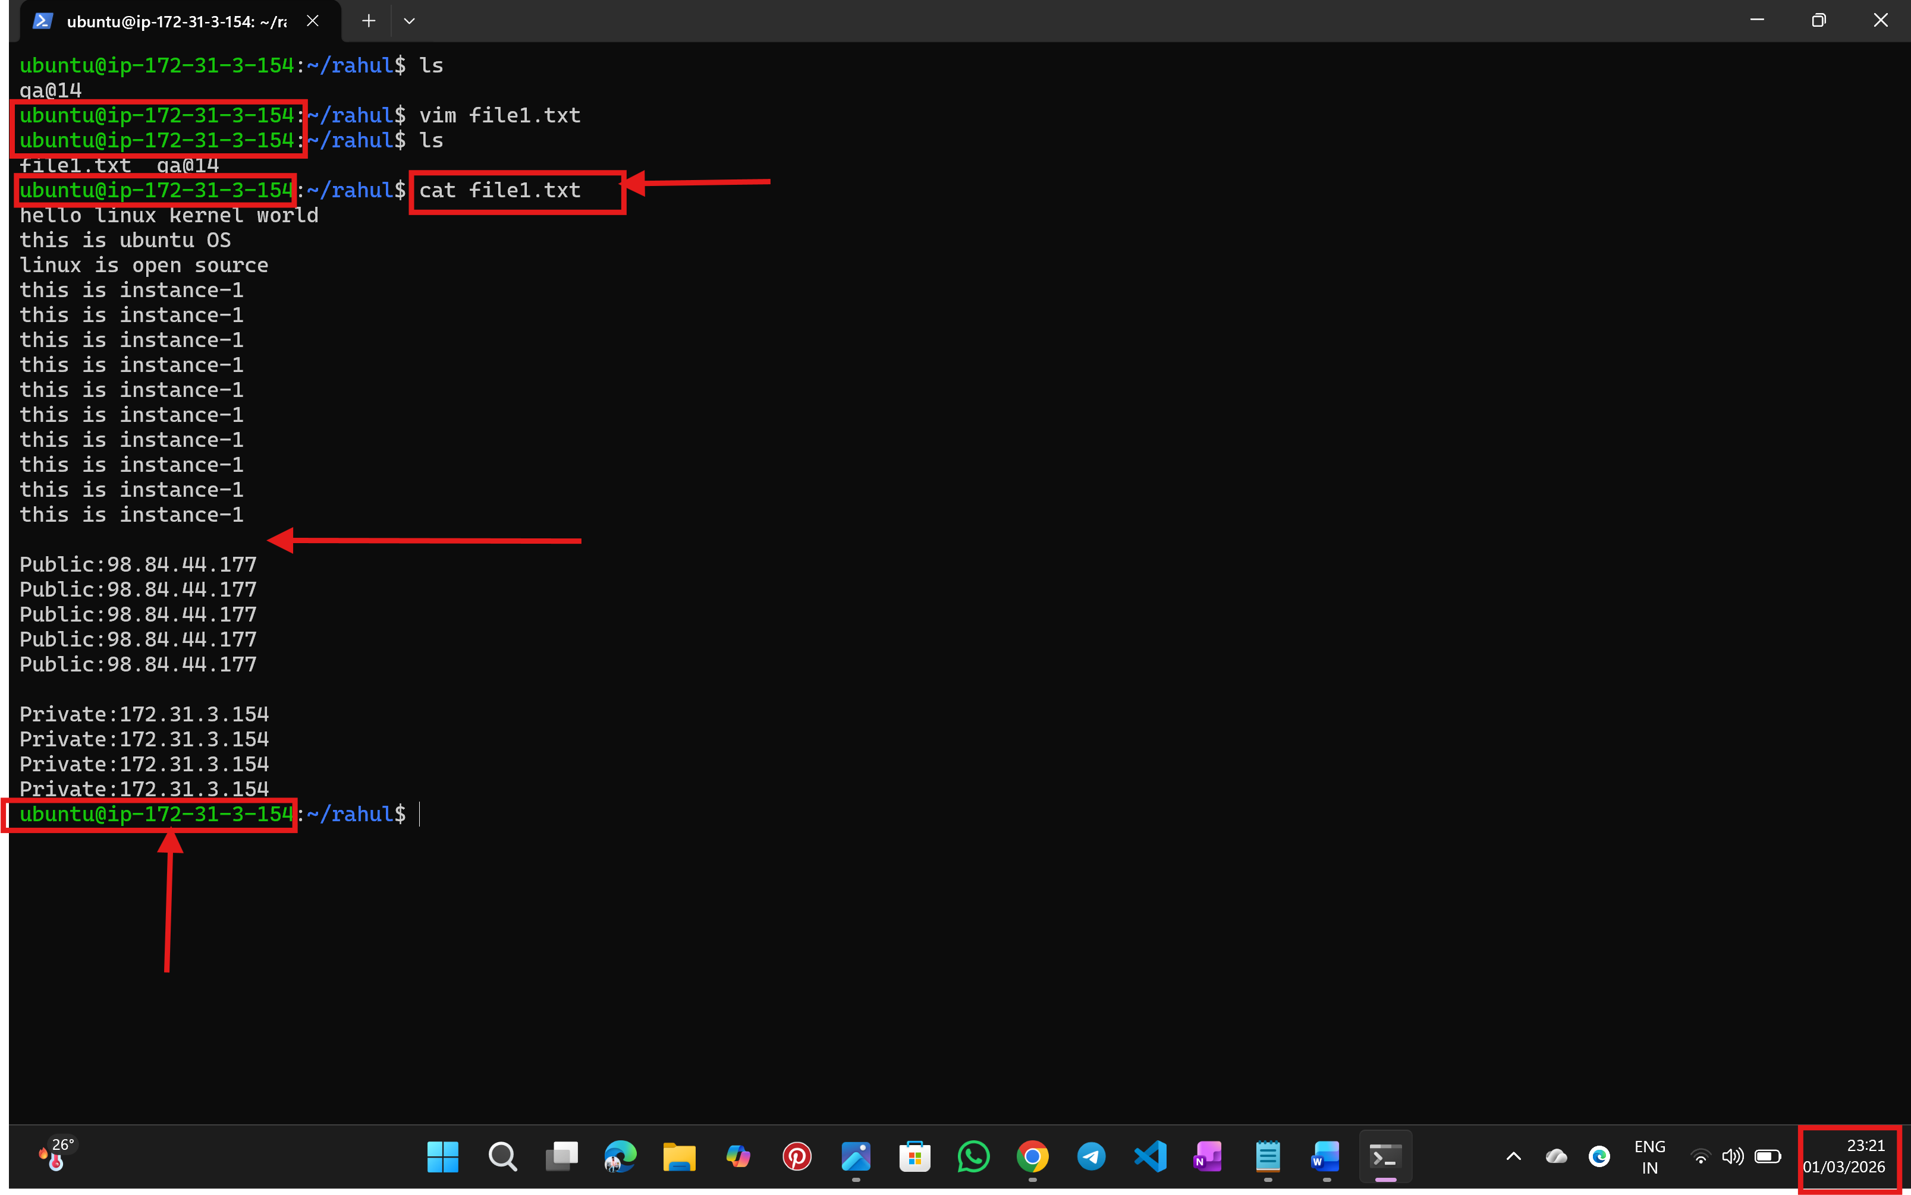

Step: 6 logins into instance-2 by SSH
- Verify the files whether copied are not
- Use ls command
- So, in below we can see files copied from insrance-1 to instance-2 because used command SCP
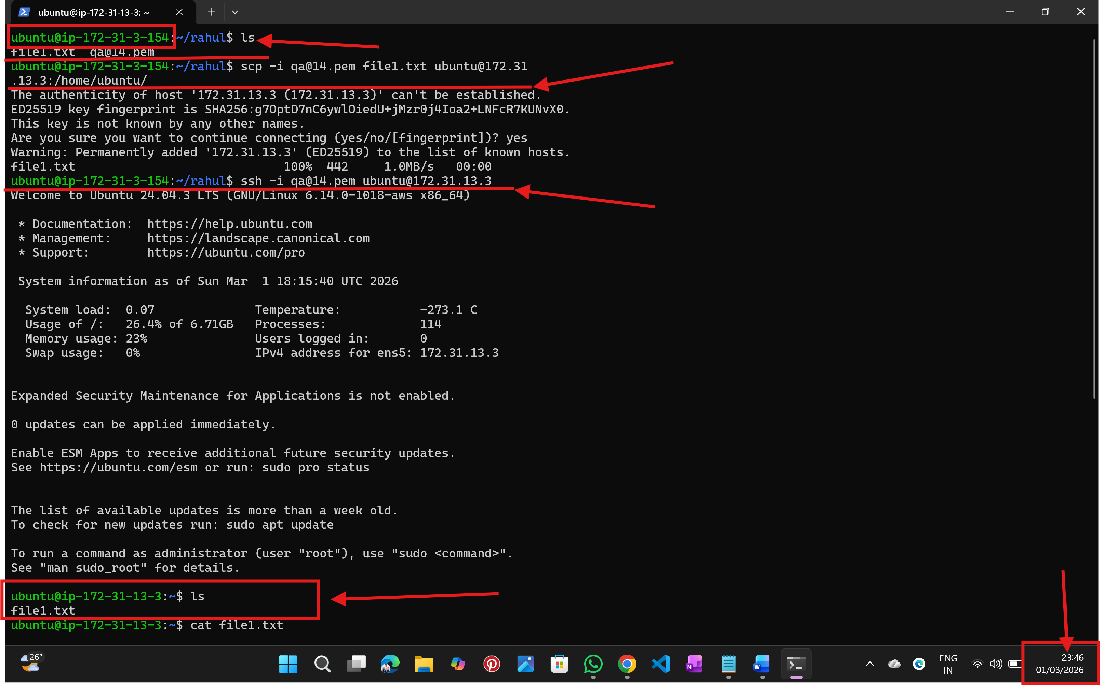
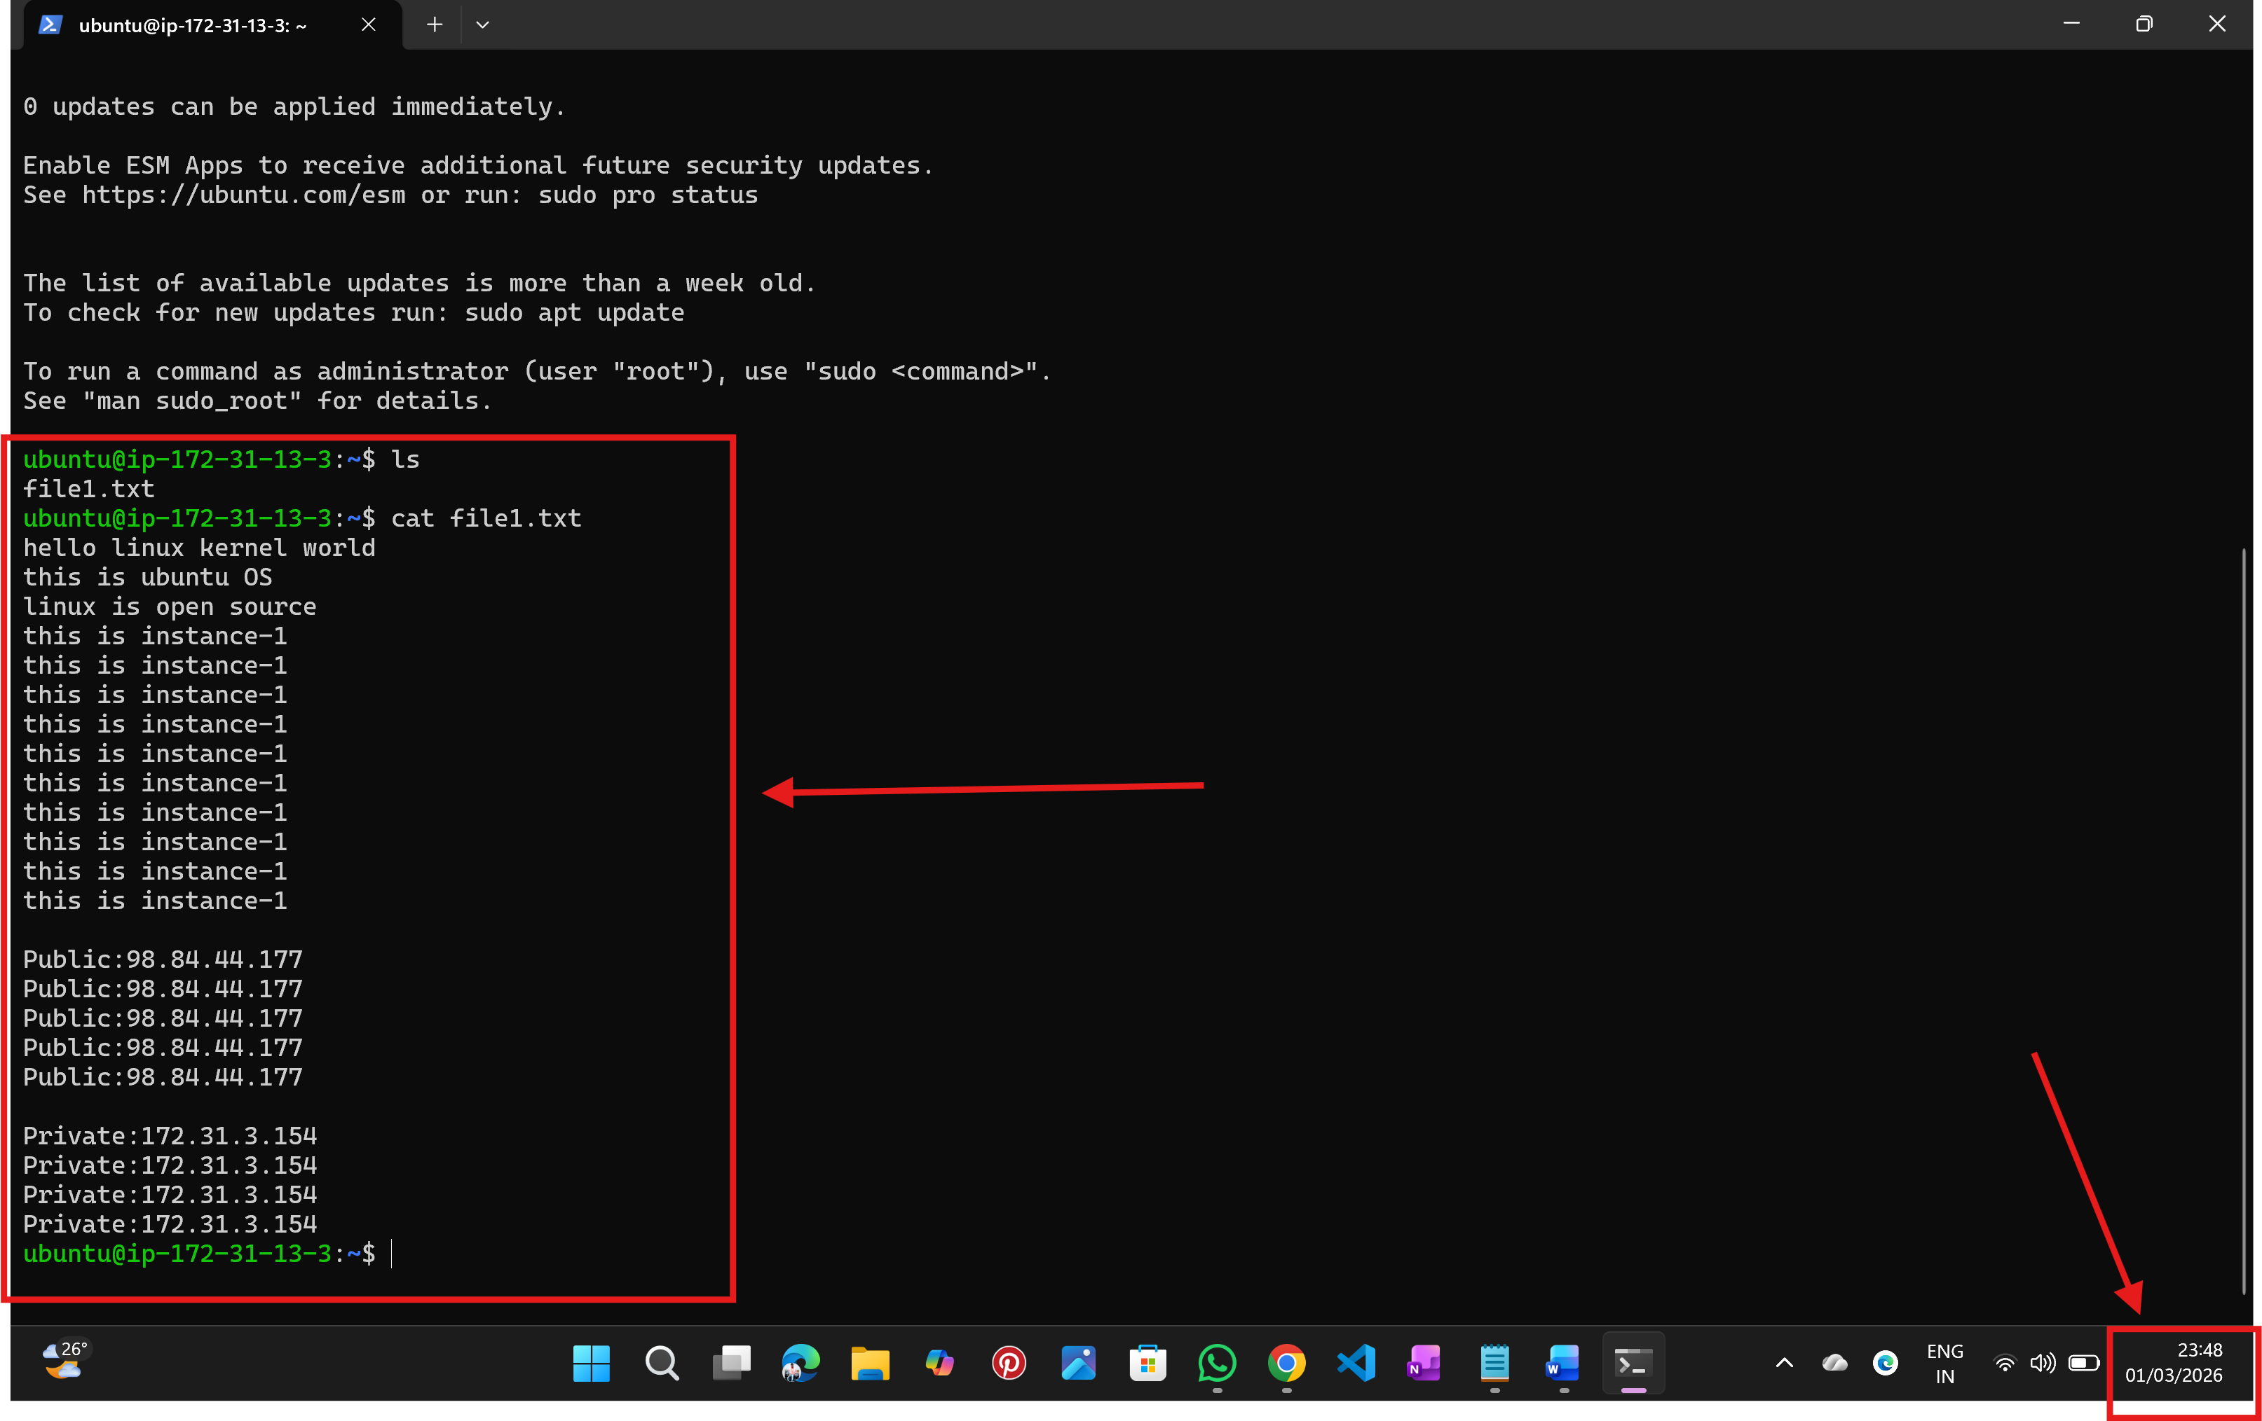

-----------------------------------------------------------END---------------------------------------------------------------------

NALATHATI RAHUL

